**Library Management System**

Digital Library

Welcome to the Library Management System (LMS), a comprehensive web-based solution designed to simplify library operations.

Explore the system's streamlined book and user management features, enhancing user experiences throughout the library.

# Access the System

To access the system, follow the given steps

Required: Any Web Browser.

1. Open your web browser
2. Enter **localhost/lms/index.php** in the address bar.

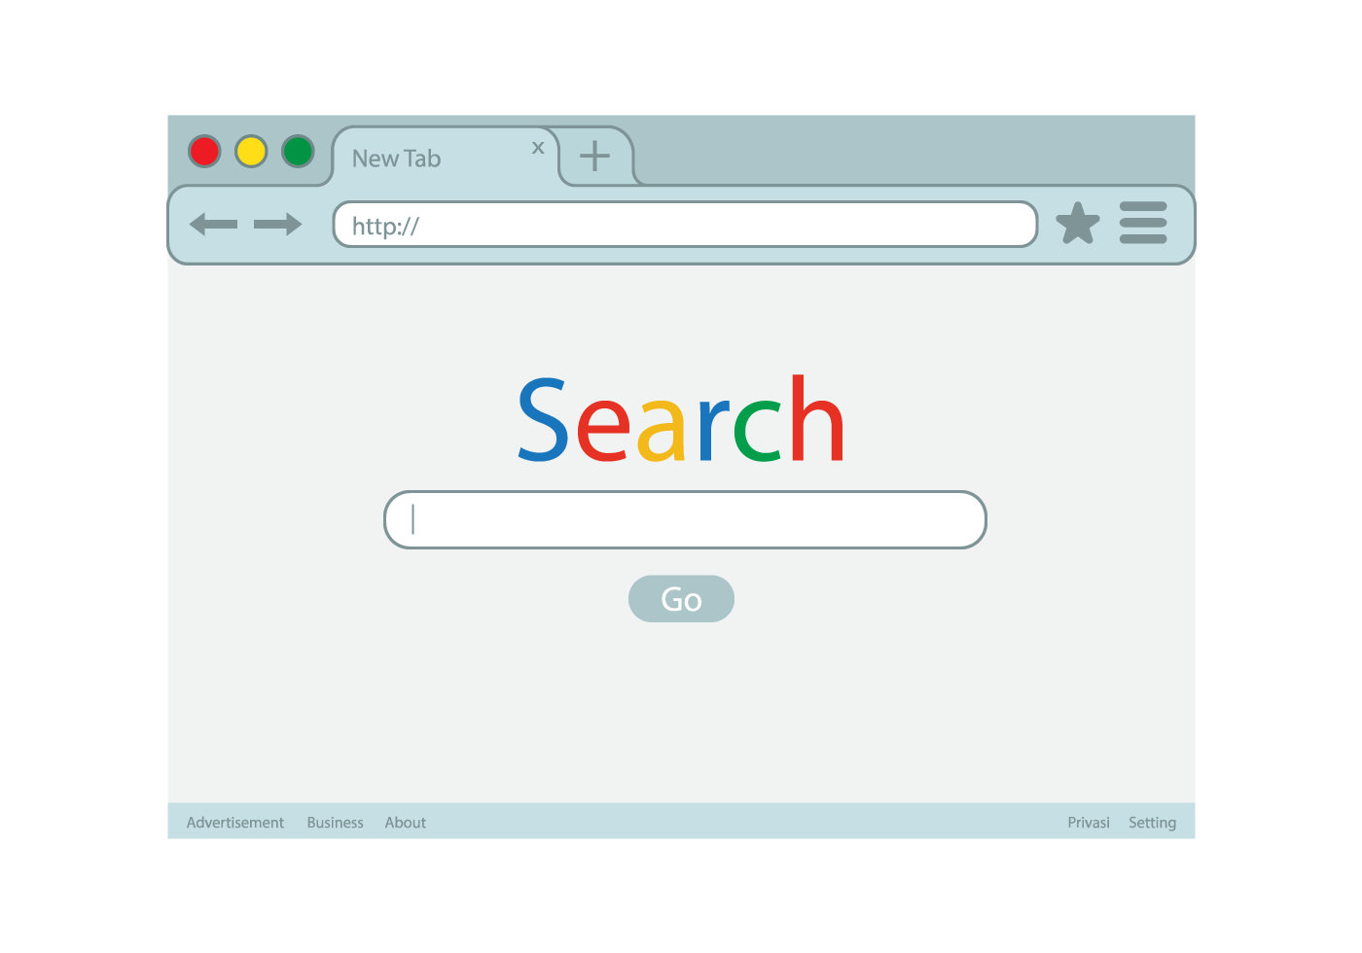

Localhost/lms/index.php

**Localhost/lms/index.php**

Don’t search the link on google, instead search it on search bar as shown in green coloured.

# Manage Books

In **Manage books** section admin can see all the books which are added previously and there is search functionality to find the books easily. Admin can also add new books and delete the existing one.

Steps:Add New Books

1. Navigate to **Books** from the sidebar.
2. Click on **Add Book** on the right corner of page.
3. A **Form** will appear, fill the form with required information and hit Enter.

Now the book will be added and can be seen in Books Page.

Steps:Delete Books

1. Navigate to **Books** from the sidebar.
2. Search the Book and Click on **Dustbin Icon**.

# Manage Users

In **Manage Users** section admin can see all the users which are added previously and there is search functionality to find the users easily. Admin can also add new users and delete the existing one.

Steps:Add New Users

1. Navigate to **Users** from the sidebar.
2. Click on **Add User** on the right corner of page.
3. A **Form** will appear, fill the form with required information and hit Enter.

Now the User will be added and can be seen in Users Page.

Steps:Delete Users

1. Navigate to **Users** from the sidebar.
2. Search the User and Click on **Delete Button**.

# Manage Records

In **Manage Records** section admin can see all the records which are added previously and there is search functionality to find the records easily. Admin can also add new records and delete the existing one. If someone return the books the admin can use a button named “Return” to update the records.

Steps:Add New Record

1. Navigate to **Records** from the sidebar.
2. Click on **Add Record** on the right corner of page.
3. A **Form** will appear, fill the form with required information and hit Enter.

Now the Record will be added and can be seen in Records Page.

Steps:Delete Records

1. Navigate to **Records** from the sidebar.
2. Search the Record and Click on **Delete Button**.

Steps:Returned Books

1. Navigate to **Records** from the sidebar.
2. Search the Records and Click on **Return Button**.